**PROPERTY MANAGEMENT APPLICATION USING SALES FORCE**

**1 OVERVIEW**

* 1. **INTRODUCTION:**

**This developer app is used in property management for buyer needs**

**PURPOSE:**

**It is a management software that allows buyer buying capacity**

**{Empathy Map}**

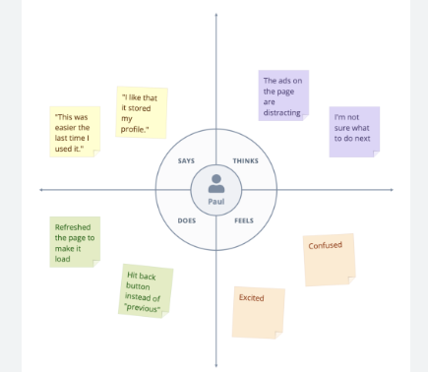

**{Brain Storming}**

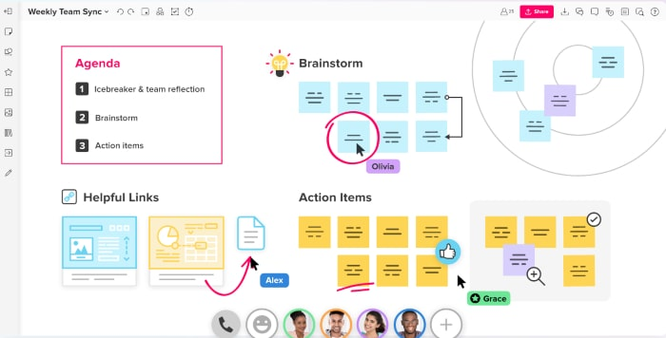

**Data model:**

|  |  |  |
| --- | --- | --- |
|  | Field label | Data type |
| Object 1  Object2  Object 3  Object 4 | Customer name  Contact number  Address  Budget | Text  numeric  Text  Rs.Number |

**4 Trailhead profile public URL:**

**Team lead : https://trailblazer.me/id/akumar8420**

**Team member 1:** [**https://trailblazer.me/id/kratos22**](https://trailblazer.me/id/kratos22)

**Team member 2: https://trailblazer.me/id/bala42**

**Team member 3:** **https://trailblazer.me/id/dhayr5**

**Advantages :**

* **Provides higher buying potential of candidates**
* **Ensure reliable customer .**

**Disadvantages:**

* **Limited choices of software .**

**Application :**

* **It help to find customer buying nature of land and house.**

**Conclusion :**

* **This software helps to analyse the product buying nature of house and land .**

**Future scope :**

* **This teachnology is used business operation of buying capacity of customer in property .**